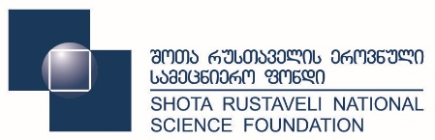
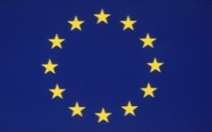
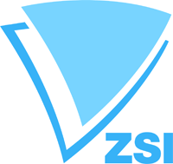

Horizon 2020 Information Day
NCP workshop

May 30, 2016
Hotel Holiday Inn Tbilisi
Tbilisi, Georgia

09:00 – 09:30 Registration of participants

09:30 - 09:50 Welcome Addresses
Ms. Ketevan Natriashvili, Deputy Minister
Ministry of Education and Science of Georgia

Ms. Marine Chitashvili, Director General
Shota Rustaveli National Science Foundation (SRNSF)

Mr. Vincent Rey, Head of Cooperation at the Delegation of the European Union to Georgia

Dr. Klaus Schuch, Scientific Director.
Zentrum für Soziale Innovation (ZSI)

Session I Horizon 2020 Opportunities

9:50 - 10:10 Introduction to Horizon 2020
Mr. Stephen Sadler
European Commission, DG Research & Innovation, International Cooperation Directorate, Unit C.3 - European Neighborhood, Africa and the Gulf

10:10 – 10:30 Practical information on participation
Ms. Teodora Balau
MSCA - Cooperation with EaP countries, Russia and Central Asia

10:30 – 10:50 European Research Council grants
Dr. Alice Rajewsky, Head of Sector – Humanities, European Research Council Executive Agency ERCEA.B.5 - Social Sciences and Humanities

10:50 - 11:10 Marie Skłodowska-Curie Actions
Ms. Teodora Balau, MSCA - Cooperation with EaP countries, Russia and Central Asia
11:10 - 11:30 InnovFin
Mr. Marc D’hooge, InnovFin Programme Manager, InnovFin,
EU Finance for Innovators, European Investment Bank

11:30 – 11:50 Coffee break

Session II Support of the National Contact Points

11:50 – 12:10 Ms. Natia Gabitashvili
H2020 National NCP Coordinator
Ministry of Education and Science of Georgia

12:10 – 12:30 Ms. Stella Shapoval
H2020 National NCP Coordinator
Deputy Head of International Cooperation and European Integration Department; Head of Division for International Scientific and Technical Cooperation, Ministry of Education and Science of Ukraine

12:30 –12:50 Ms. Małgorzata Kapica
Coordinator of Polish NCP Network
The Polish National Contact Point for Research Programmes of the European Union (KPK), Institute of Fundamental Technological Research, Polish Academy of Sciences

12:50 – 13:10 Feedback from successful Horizon 2020 grant holders, invited experts and local grant holders
Ms. Anastasia Vlyzioti,
Centre for Regional and International STI Studies and Support – CeRISS
Lessons learnt from the IncoNet EaP Support to NCPs

13:10 – 13:30 Horizon 2020 projects from Georgia
Dr. Nana Macharashvili
Ivane Javakhishvili Tbilisi State University; Faculty of Social and Political Sciences

13:30 – 14:30 Lunch break

Session III Parallel Sections:
A - InnovFin Programme Workshop
B - Horizon 2020 National Contact Points Presentations

Section A-14:30 – 16:10 InnovFin Programme Workshop
Marc D’hooge, InnovFin Programme Manager, InnovFin,
EU Finance for Innovators, European Investment Bank

Section B - 14:30 – 14:50 Ms. Natalia Shatirishvili (H2020 NCP in Energy)
14:50 – 15:10 Mr. Givi Kochoradze (H2020 NCP in ICT)
15:10 – 15:30 Mr. Zurab Kighuradze (H2020 NCP in MSCA)
15:30 – 15:50 Ms. Maia Okujava, (H2020 NCP in Health)
15:50 – 16:10 Q&A

16:10 – 16:30 Coffee break

16:30 – 16:50 Mr. Boka Tabatadze, SME instrument/Innovation in SMEs/new opportunities for Georgia SMEs in H2020
Enterprise Europe Network – Georgia

16:50 – 17:10 Ms. Mariam Lashkhi - Georgia’s Innovation and Technology Agency (GITA - H2020 NCP for Future Technologies)

17:10 – 17:30 Discussion and closing remarks

